

_____________________________________________________________________

Web API get and post request according to the DeviceID

This document explains how the device and data request can be made via WebAPI. The program is written in c#, and MSSQL is used to record the data posted.

Steps to run the program
- Restore the database to the SSMS, and try to modify the connection string according to your system credentials

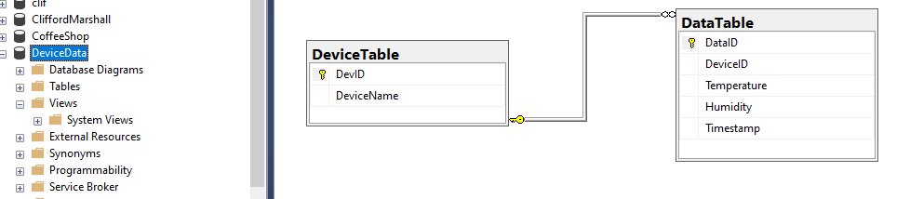

- Run the program in visual studio, with ISS server (This provides the localhost port where the server is running)

- Open the postman application, and send get request via the api to get the no of records of data sent by each Device
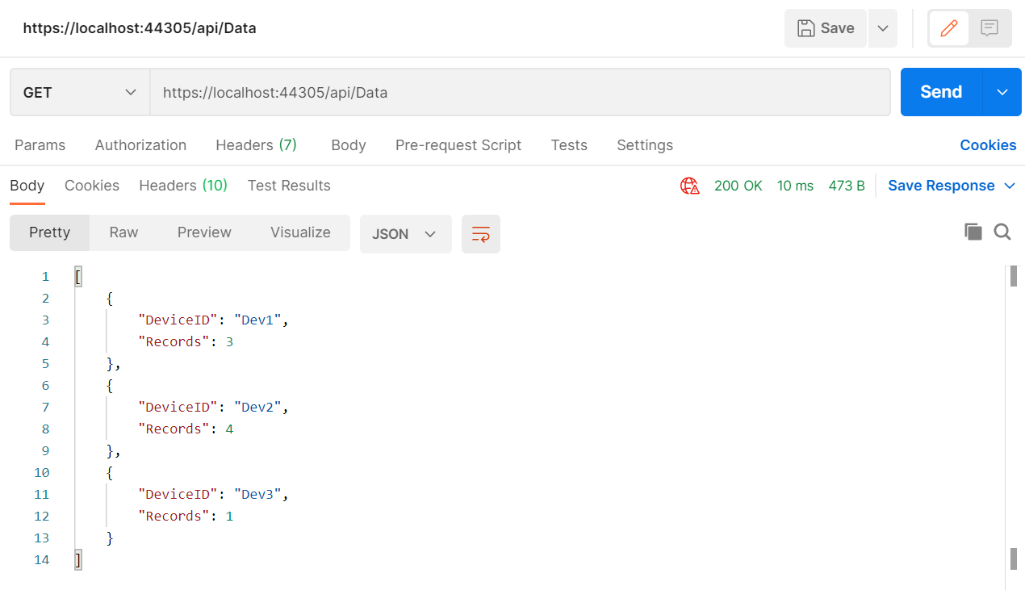

- Send a request with the Device Id to get all the data recorded for that specific device
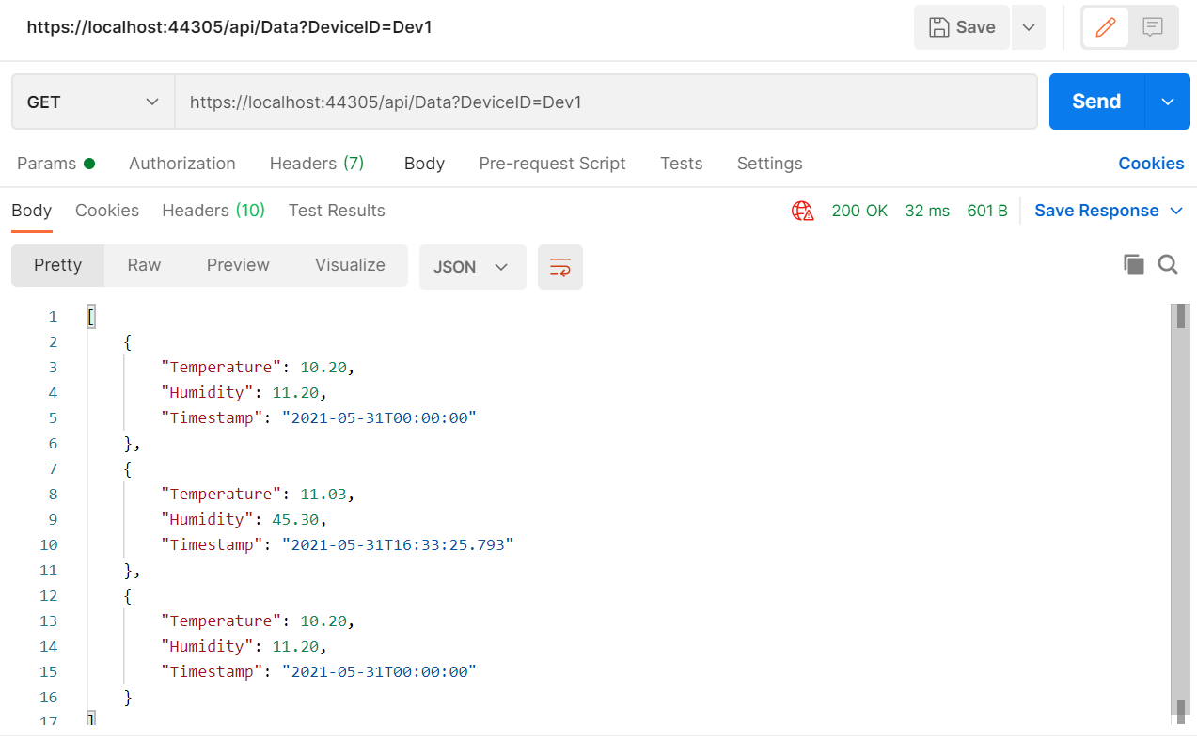

- Send a device data measurement via post request to the server. This requires the DeviceID to be already recorded in the system, ie, only verified devices can sent the measurement values, that can be recorded

